姓名 | 朱旭
教育与工作经历 | 2016-2020 浙江大学 学士 自动化+计算机科学与技术（双学位）  2021-2022 布里斯托大学 硕士 Msc Robotics  2022-2024 地平线 自动驾驶预测算法工程师
电子邮箱 | xu.zhu.sustech@gmail.com
个人照片 | 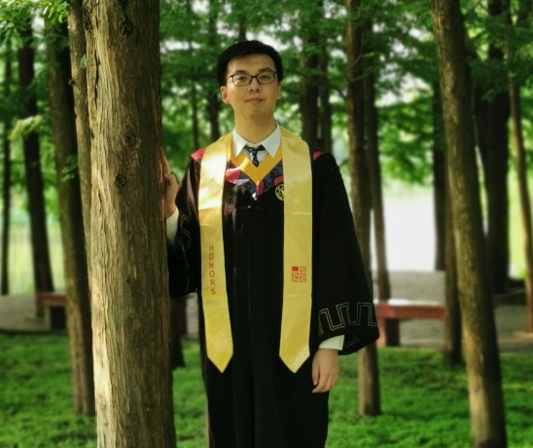
研究领域 | Intelligent robotics
自我介绍 | Hi, I'm a PhD student in BIRD Lab, SUSTech. I earned dual bachelor's degrees in Computer Science and Automation from Zhejiang University followed by a Master's degree in Robotics from the University of Bristol. Then I worked for two years as a prediction algorithm engineer at Horizon Robotics (a leading autonomous driving/robotics company in China). With a strong interest in intelligent robotics, my current research focuses on the hardware design and intelligent control of bio-inspired humanoid robots.
论文发表情况
*填写完成后删除括号内原文和示例图片

